Shabbos Stories for
The yahrtzeit of
Noach lipschutz
Volume 13A, Issue 9 - 30 Tishrei/October 18, 2021
Printed L’illuy nishmas for my father-in-law Noach (Norman) ben Nechemia

For a free subscription, please forward your request to keren18@juno.com
Past stories can be found on the website ShabbosStories.com

Shliach’s Solution to Street Performers’ Turf War
By Rabbi Pini Zaklas of Zagreb, Croatia

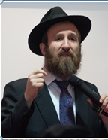
Rabbi Pini Zaklas

The Chabad House in Zagreb sees many visitors. Daniel, an American Jew, is one whom we’d come to know personally.
Born in Washington DC, Daniel left home in the seventies to see the world. Now, fifty years later, he and his flute are still traveling. When he arrives in a city, Daniel scouts out a busy street corner in the center of town and sets himself up. Sometimes his performance includes a juggling act with whistling balls, other times an assortment of self-made instruments accompany his flute. His plastic flute has been his piece de resistance during his stay in Zagreb.

A Shabbat Guest
In normal times, once he’s earned enough money from pedestrians, Daniel takes off in search of a new street corner in a new city. I’m not sure if it’s the coronavirus pandemic or the charm of Zagreb, but Daniel seems settled here. On Shabbat, he’s our house guest.

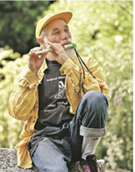
Daniel

During the week, he stops in to say kaddish for his mother, who passed away earlier this year. And when he’s not with us at Chabad, he is performing. It’s been a whole year, and Daniel and his musical performances are now a fixture on Ilica Street, not far from our Chabad House.
An Optimistic Soul
An optimistic soul, Daniel always wears a cheerful smile, so when I saw him a month ago, his expression told me something was off. “A street-guitarist has moved onto Ilica a few meters from me,” he lamented. Much to his consternation, the novel act was commanding the attention of passersby, and Daniel’s earnings were shrinking. I listened to him, not sure how I might help him out of his dilemma.

Roberto

A Guy Named Roberto
Late one evening, I got a call from a guy who introduced himself as Roberto. His father had passed away abroad. I invited him to come by in the morning to perform the mourning rites and recite kaddish.
Morning came, and I helped Roberto do the ritual of kria’h (a
mourner rends their garment and wears the torn garment for the week of shiva) and then lay tefillin.
As he placed the tefillin on his head, Roberto asked me, “Are you mad at me, Rabbi?”
My mind began to race through possibilities, “Why would I be mad at this stranger?”
“When you pass me playing my guitar on Ilica Street, you don’t say hi,” Roberto explained. And then it occurred to him: “Oh, Rabbi, you don’t recognize me!” I didn’t. “You came to visit me in jail twelve years ago,” Roberto said. “You brought matzah and books.”
I remembered. It was 2008, a day before Passover, when I received an urgent call from my colleague in Caracas, Venezuela, Rabbi Yehoshua Rosenblum. A Venezuelan expat found himself jailed in the city of Split, in southeast Croatia. Would I visit him before the Holiday began?

Gave Him Matzah
And Jewish Books
I made the four-hour drive from Zagreb to the prison facility in Split. The Jewish inmate sat huddled in the cell that he shared with three others. We talked for a little while, and I gave him the matzah and Jewish books that I’d brought. I hoped that, in some way, I had lifted his spirits in those
wretched surroundings. Then I drove back to Zagreb to finish preparations for Passover.
Years passed, and I’d forgotten about this. But Roberto hadn’t. And now, here he was, saying kaddish for his dad. And then I connected the dots: Roberto is the street-guitar player, Daniel’s contender!
As I continued speaking to Roberto, Daniel walked in, as usual, to recite the mourner’s kaddish for his mom. Seeing his rival in the Chabad House talking to me, his jaw dropped.
When the prayers ended, I invited Daniel and Roberto to sit down together. I knew that I had to find a way to make peace between these two men, each one saying kaddish for a parent, both of whose lives had intersected on my doorstep.
After some conversation, we arrived at an amicable resolution, and Roberto and Daniel accepted the terms: separate times for respective solo street performances, set times for duets when both would perform together, and a socially-distance concert at Chabad featuring them together.
By the time we were done and Daniel and Roberto left the Chabad House, they had their arms around each other’s shoulders, comrades in music on the streets of Zagreb.

Reprinted from the Fall 2020 issue of Lubavitch International.
My Date 'Dumped Me'
For My Best Friend!
By Karen Kaplan

Art by Yitzchok Schmukler.

I graduated from public high school more than 50 years ago. It’s hard to believe, because it seems like yesterday. Time becomes an accordion as you age. Sometimes memory squishes the long ago and the now close together, sometimes it stretches it out. The story I’m about to share is as vivid as if it happened yesterday. When you read it, I think you’ll see why.
It happened long ago, long before I had learned much of what I now know about Judaism, including the fact that halachah does not allow for mixed dancing. However, the message it taught me is so powerful that it still bears telling.
One of the traditions during high school was the Homecoming Dance. Girls would anxiously wait for boys to ask them to this event, boys would nervously rehearse their asking, and like the animals entering the Ark, pairs would match up. Dresses were bought (pastels and satin were all the rage back then), tuxedos rented, corsages purchased, and for one grand and magical evening, I could trade my plaid skirt, ponytail and knee socks for a gown, pumps, and an up-do. Ah, the glamour of it all!
Back then, I had a major crush on David. He was gangly, and wore glasses, and his 1960’s hair made him look like a mophead, but to me he looked like Paul McCartney (the “cute” Beatle). My best friend, Sarah, told me she’d talked to her brother, Aaron, who knew Allen, who was friends with David, and through the high school grapevine I was assured that David liked me too.

Delighted to Be Invited to the Prom!
And to my delight, David asked me to the prom! I was very excited and spent every waking moment dreaming of our perfect evening while I practiced walking in my first pair of heels. I picked out a mint green, long satin dress, bought some pink frosted lipstick, and found the perfect mint eyeshadow to match my dress. Hey, it was the 60’s, ok? Meanwhile, David made reservations at a fancy restaurant, rented his own mint green tuxedo, and hired a limousine and driver to chauffeur us. I was a princess, he was Prince Charming, and in my mint green fairy tale we’d live happily ever after.
Then, three days before the prom, my fairy tale was shattered. David called to tell me he couldn’t take me to the prom. I asked for the reason, and he just stammered, said he was very sorry, and quickly ended the conversation. I was devastated and confused and hoped it would be made clear at school the next day.
Sure enough, between classes, I caught sight of him in the hall. He was huddled in conversation with Sarah, my best friend. From a distance I saw them nod in unison and give each other a smile and a high five. Aha! All had become clear. David had dumped me and asked Sarah to the dance instead! I locked myself in a bathroom stall and cried, and then pulled myself together, vowing to give both the cold shoulder. I would keep my dignity, stay aloof, and not say a word to either of them.

Ignored Sarah and Avoided David
When lunchtime came, I ignored Sarah and sat with another group of friends. When she called that evening, I said I was busy and couldn’t talk. David tried to talk to me after school, and he looked upset and tense, but I walked right on by, head held high. He should be upset, I thought! He dumped me for my best friend! I seethed inside, imagining him and Sarah at the dance together. My feelings were hurt, but I consoled myself knowing my pride was intact. I snubbed them the next day, too.
On the evening of the dance, my parents took me out to a nice restaurant. My mother had returned my dress and shoes, and I promised myself that I’d never buy anything in mint green satin again (a promise I’ve never regretted). And thus, the evening came and went, without my having talked to either Sarah or David. The next day, Sarah cornered me at my locker and demanded to know why I was mad at her.
“How can you not know?”, I blurted out. “You went to the dance with David!” She looked at me in astonishment, and said, “What are you talking about?” I told her I’d seen them huddled in the hall, smiling and high-fiving, and she reminded me they were in the same math class, and were merely comparing answers on a test they had just taken. They were pleased they’d both gotten the extra credit question right! With that, she marched off, miffed that I could have thought such a dastardly thing of her.

David’s Explanation
That evening, the doorbell rang. It was David. This time, I let him talk. He confided that his father had lost his job several months before. His family was struggling financially, and David had been embarrassed to tell me. In fact, they couldn’t buy groceries that week, and the night he’d called, he’d just given them his savings, earned by washing cars and mowing lawns, money he’d planned to spend taking me to the dance. His father had walked into the room while we were on the phone the night he called to cancel, and David didn’t want to embarrass him, so he quickly ended the conversation. He planned to explain it at school the next day, but I never gave him the chance. I’d assumed the worst of both him and Sarah.
Few things hurt as much as a broken heart or a guilty conscience. And I had both, piled on top of the emotional melodrama of adolescence. I wanted to dig a hole and crawl into it. Even now, 50 years later, the echo of that pain remains. I apologized to both of them, more than once, but the damage was done. Sarah remained a friend, but no longer my best friend. And David never asked me out again.

Judge Each Person Positively
Pirkei Avot (1:6) says: “dan l’chaf zechut”, judge every person meritoriously. Only G-d knows everything that goes on in a person’s mind and life, while we humans see merely a snapshot. It’s our responsibility to search for ways to interpret what others say and do in a positive light, giving them the benefit of the doubt, as we’d want them to do for us. We must ask ourselves, “What situation could possibly make ME say or do that?” Perhaps the fellow who just cut me off in traffic is rushing to the hospital because his wife is having a baby. Perhaps the rude clerk in the store had her car break down and can’t afford to fix it. Perhaps David had a family emergency of some kind.
G-d is good, and we are created in His image. Therefore, there is good in all of us. We must seek it out. We must presume it, and as much as we can, judge people in a positive light. It’s been close to 50 years since I saw David or Sarah. We graduated and went our separate ways. I learned a valuable lesson from them, but wish I’d learned it without hurting them. If I could, I would tell them how that event changed me forever. I learned the hard way to dan l’chaf zechut, to judge others well.

Karen Kaplan, a native Chicagoan, lives in Evanston, IL, where she actively volunteers in the community.

Reprinted from the Parshat Shoftim email of Chabad.Org Magazine.

African Pastor Becomes
An Orthodox Jew:
A Dramatic Dream Transforms the Gordon Family’s Destiny

Shmuel (Sam) Gordon was born and raised in Nigeria, Africa’s mot populous country with a population of more than 200 million. Shmuel was a sickly child and it was uncertain whether he would survive; indeed, he endured two near-death experiences. Then, at age 17, Shmuel had a “miraculous healing” and to show his gratitude, he devoted his life to G-d. Raised as a Christian (Nigeria is approximately 50% Muslim and 50% Christian), Shmuel attended seminary and at age 20 became a pastor. Renowned as a dynamic speaker and intellectual thinker, he led a church serving 1,000 people.
In 2005, Shmuel, his wife Shoshana and their three children moved to South Africa, where Shmuel started a congregation in Johannesburg’s Roodepoort neighborhood. His popularity soared – appearing regularly on TV and radio, and traveling throughout Africa preaching Christian gospel. Shmuel also trained other pastors, opening branches of his church in Ghana, Nigeria, and the United States (Texas and Georgia). Life was grand.

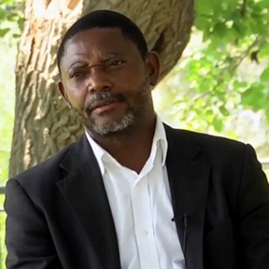

One night in 2011, Shmuel had a dream that would change his family’s destiny forever. “In the dream, a man engaged me in physical battle,” he tells Aish.com. “He would not let me go, and kept yelling: 'Now is the time to choose Israel!’”
The dream lasted all night, until Shmuel awoke frantic, shaking with the chills. “I didn't know what it all meant,” he recalls. “Dreams come and go, but this felt like much more.”
Soon after, a pastor from Norway invited Shmuel to a pro-Israel conference, and he became inspired to adopt pro-Israel activism in “response” to the dream. Shmuel founded the Africa-Israel Initiative to mobilize Christian leaders across Africa – counteracting anti-Israel media bias and speaking out against BDS and phony “Israeli Apartheid.”
Shmuel led delegations to Israel and organized huge pro-Israel rallies and conferences across Africa – in Kenya, Tanzania, Uganda, Congo, Ghana, Zambia, South Africa, Nigeria, and Rwanda. To show solidarity with the Jewish people, Shmuel would often wear a tallit and kippah while leading throngs in the streets with pro-Israel banners, t-shirts and Israeli flags.
Speaking at a conference in 2014, Shmuel issued a clarion call to the African continent: “If you believe in the Bible, you must love Israel,” he said, thrilling the large crowd with his oratory skill and knowledge of Jewish history. “G-d’s covenant with the Jewish people is unshakeable, irreplaceable, immutable, irrevocable, and has no expiration date.”

Shmuel Gordon organized huge pro-Israel rallies across Africa.

Shmuel believed that by honoring G-d’s words to Abraham thousands of years ago – “Those who bless you, I will bless” (Genesis 12:3) – a new spirit of creativity, wealth, and spirituality could be unleashed throughout Africa.
Hidden Knowledge
Meanwhile, Shmuel was undergoing a noticeable transformation in his own religious observance, with his church sermons less Christian in content and increasingly more about Israel.
This process accelerated in 2013 when, on a trip back from Israel, Shmuel noticed a Jewish passenger intently reading a book. Intrigued, he approached the man and inquired; it was the Garden of Wisdom by Rabbi Shalom Arush.
Back in Johannesburg, Shmuel found a Jewish bookstore and devoured the book cover to cover. “I never realized that such wisdom existed,” he says. “From a Christian perspective, we were trained to think that the dynamic, flourishing religious Jewish community had basically ended 2,000 years ago with the exile – and that Christians were the new ‘chosen nation.’ When I read this book, I felt like a whole world of Jewish knowledge had been hidden from us.”

To show solidarity with the Jewish people, Shmuel appears in tallit and kippah at a pro-Israel conference.

Shmuel got every Jewish book he could find, building up a library and sharing that wisdom with his family. “It was like opening a floodgate,” he says.
Shmuel purchased a Siddur and in 2014 the family began observing Shabbat. “For 24 hours, there was no work, no TV, no shopping,” says his oldest son Binyamin who was in high school at the time. “I was very into music, playing piano, and my band appeared on South Africa's Got Talent. But I put everything on hold to observe Shabbat. We'd sit around studying Torah, and then on Sunday attend church.”
One day, Shmuel came home and announced that the family was now keeping kosher. “We stopped buying meat, and instead would go to a farm, buy our own livestock, and have it slaughtered as best we knew,” Shmuel says. Then, given the Torah prohibition against eating animal blood, they would pour coarse salt on the meat and let the blood drain into their backyard barbeque pit.
Increasingly, Shmuel shared Torah ideas with his congregation. “My sermons attacked the fundamentals of Christian theology,” he recalls. “I told the congregation that the Trinity was a man-made invention and that we should pray not to an intermediary, but to one G-d.”
Shmuel pushed the envelope further by instructing the church choir to remove the name “Jesus” from all the songs at Sunday services.
“My life was torn in two,” he recalls. “The more Judaism I learned, the more disconnected I felt from Christianity. We stopped celebrating the various holidays. After nearly 30 years as a pastor, Sunday mornings had become my worst time.”

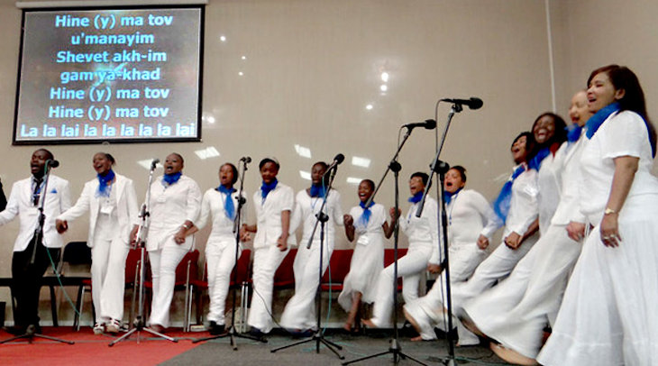Shmuel’s church choir leads a rousing rendition of a popular Hebrew song
(lyrics projected on screen).

Closing the Church
The levee broke one Saturday night in 2016. Shmuel couldn't sleep, and the following morning – while delivering the Sunday sermon – courageously broke the news. “I told the congregation that I'd been doing research about my tribal heritage in Nigeria, and discovered that I’m Israelite,” Shmuel recalls. “I told them: ‘You're welcome to go wherever you want, but my family and I cannot continue practicing a faith we no longer believe.’
“Then I told them that, effective immediately, the church was closed.”
Chaos and commotion ensued. Some congregants viewed Shmuel as a traitor and issued death threats. Other congregants approached him saying they wanted to follow his Jewish path. So Shmuel formed a Noachide community and began meeting on Shabbat. From time to time, rabbis came from Israel to teach them the basics.

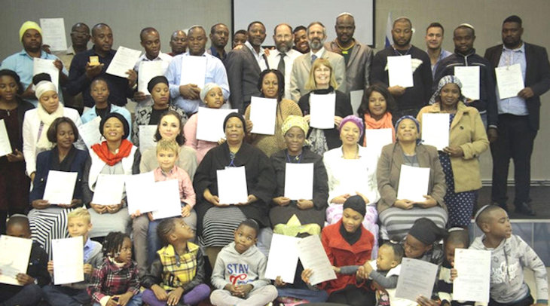Some church members formed a Noachide community that meets on Shabbat.
(Shmuel is in the back row, center.)

Meanwhile, Shmuel redoubled his efforts for Israel advocacy. He resigned from the Christian group he'd founded, and joined forces with SAFI – South African Friends of Israel. There he found a kindred spirit in SAFI executive director Gavriel Sacks, whose mother had converted to Judaism.
Shmuel decided to become a Jew.
What about the Gordon family? “I didn't force anything on them,” he says. “I shared Jewish books and let them embark on their own journey. My wife was initially skeptical, and all three kids at the time were teenagers. But remarkably, they each discovered the truth of Torah for themselves.”
With the family united in resolve to become Jewish, they met with the highly-respected Johannesburg Beit Din and were accepted into the conversion program. They moved to a Jewish community, and underwent a daunting, two-year process. In August 2019, after a rigorous final exam in Beit Din, the Gordon family became Jewish.

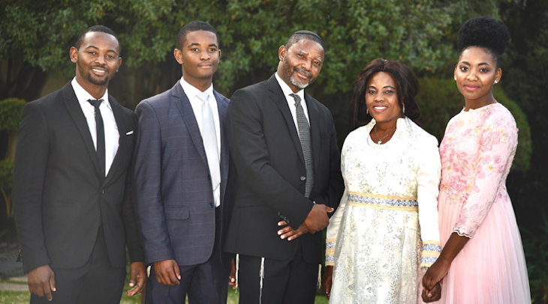The Gordon family (L-R): Binyamin, Dovid, Shmuel, Shoshana, OriElla.

Today, five of Shmuel’s former congregants are undergoing the conversion process, and more are expected to join. I ask Shmuel if it’s a challenge, given the small number of blacks in the South African Jewish community. “The Jewish community welcomed us very fast,” he says. “We never experienced any kind of discrimination.”
Binyamim, the eldest Gordon child, age 25, visited Israel recently for the first time on an Aish program. “When I got to Israel, people were speaking a different language, yet everything seemed so familiar,” he told Aish.com. “I felt like I'd been here before, that I was returning to a place I’d left long ago. I'm home.” He is now studying at Ohr Somayach in Jerusalem and hopes to return to South Africa this summer to arrange for aliyah.
OriElla, the Gordon’s daughter, is currently in Jerusalem studying at Neve Yerushalayim College.
The youngest, Dovid, attends high school in South Africa.
As for Shmuel and Shoshana, they have eyes set on aliyah. "I'm hoping my whole family moves to Israel, where I can study Torah the rest of my life," he says.
Shmuel is currently writing a book about his experiences, and wants to spread the light of Judaism to as many as he can. As for his native continent, he claims: “The soul of Africa was stolen many years ago. If we can connect with the Almighty in the right way, great light will come to Africa.”

Binyamin Gordon studying Talmud in Jerusalem.

Reprinted from the February 8, 2020 website of Aish.com

